**Rest Assured introduction**

* *Rest-Assured is a Java based library that is used to test RESTful Web Services. This library behaves like a headless Client to access REST web services*
* Rest Assured simple java libraries for testing of Rest WebService API
* *Rest-Assured library also provides ability to validate the Rest-HTTP Responses received from server. For e.g. we can verify the Status code, Status message, Headers and even the Body of the response. This makes Rest-Assured a very flexible library that can be used for testing.*
* It supports both XML and JSON

**Why Rest Assured is popular?**

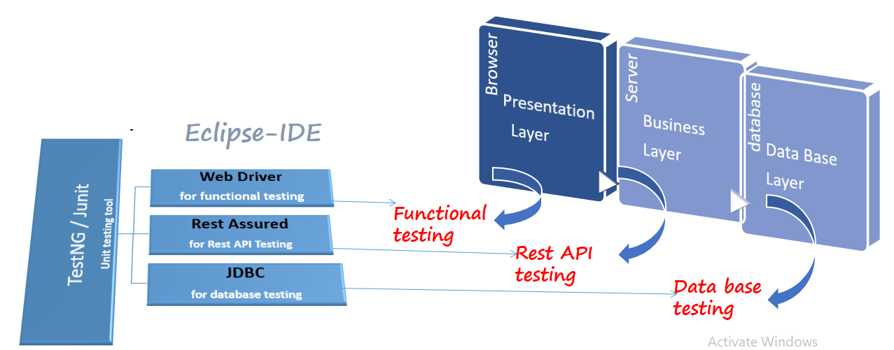

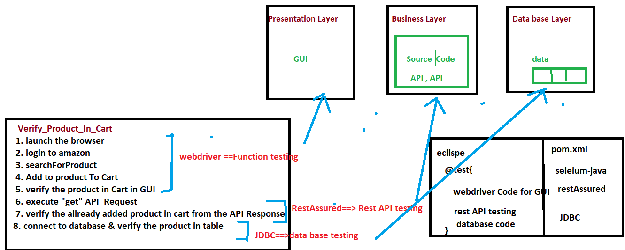

* It Can Integrate seamlessly with existing java based framework like
* Testng/junit/BDD
* Selenium Web driver
* JDBC
* So that We can Automate E2E business workflow which include all the layers

**Rest assured Advantages**

* Support for all http methods
* Support for BDD
* Use of Hamcrest matches for validation /Assertions
* Provide inbuilt method to create a request header & body
* Provide inbuilt method to validate response header & body
* Handles various authentication like Token AUTH, Basic auth, oauth1.0, oauth2.0
* Send request over the network using existing protocol like **http**
* Integrate seamlessly with existing java-based framework like selenium, testng, jdbc, poi etc.
* Used for complete backend automation
* Framework can integrate with CI/CD pipeline
* Open-source headless client

**Rest assured Project Setup**

* In order to use Rest assured client, we should create a maven project & add below dependency

**Step to create maven Project**

* open Eclipse
* create maven project
* Add below dependency in POM.xml

save pom.xml file

|  |  |
| --- | --- |
| **Tool** | **Description** |
| **rest-assured-3.0.2** | **Rest api headless client** |
| **json-simple-1.1.1** | **Used to create Json object** |
| **jackson-mapper-asl-1.9.13** | **Used to create pojo & parser class** |
| **testng-6.8** | **Unit testing tool** |

**Rest assured Class diagram**

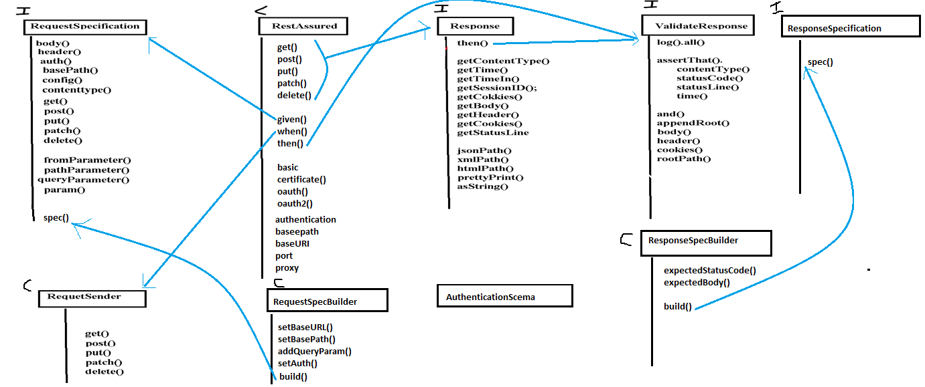

Description of Every API

|  |  |
| --- | --- |
| Rest Assured class | Description |
| RestAssured | Main class of restassured , where we can start the Rest API test using  BDD like given(), when() , then() |
| RequestSpecification | Used to set the specification of the request like authentication & parameter etc. |
| RequestBuilder | Used to create common reusable precondition code for the request |
| RequestSpecSender | Used to set precondition for the request |
| Response | Used to receive the response of the request |
| ResponseSpecification | Used to set the specification of the response |
| ResponseSpecBiuilder | Used to create common reusable precondition code for the response |
| ValidateResponse | Used to validate the response |
|  |  |
| JsonObject | used to create JSONObject |
| ObjectMapper | used for serialization |